PROFESSIONAL OPINION
A3 Environmental, LLC (A3E), in accordance with U.S. Small Business Administration (SBA) SOP 50-10 5(K), A3E reviewed reasonably ascertainable environmental regulatory database records, historical aerial photographs, city directories and historical topographic maps (if available) for the PropertyName, PropertyAddress, PropertyCity, PropertyCounty, PropertyState, PropertyZip (Target Property). Copies available historical information is attached for your reference.

Professional Opinion
ELEVATED RISK | Based on the records found in this report and any additional review performed by A3E, A3E’s opinion is that the environmental risk level for this property is ELEVATED
LOW RISK | No further assessment is warranted.

RISK SUMMARY

Government Records: The Target Property was not listed on any government databases. The surrounding properties within the standard scope were not listed on any government databases.

Aerial Photographs: The Target Property was developed for commercial purposes by 1999 (per the available historical aerial photographs). Prior to 1999, the Target Property was developed as agricultural land. The surrounding properties were developed for commercial/residential purposes by 1973 (per the available historical photographs). Prior to 1973, most of the properties were developed as agricultural land. Based on A3E’s review of available online historical aerial photographs, no environmental concerns were identified for the Target Property.

Topographic Maps: No significant features were identified on the topographic maps reviewed. Based on A3E’s review of available online historical topographic maps, no environmental concerns were identified for the Target Property.

Fire Insurance Maps: The Target Property was depicted with residential dwellings from at least 1916 through 1965. In 1975, the Target Property was developed with the existing structure. No adjacent properties or surrounding properties of potential environmental concern were identified on the maps reviewed. Based on A3E’s review of available online historical fire insurance maps, no environmental concerns were identified for the Target Property.

City Directories: The Target Property was identified in the 1925, 1976 and 1999 city directories. Occupants of the Target Property include residences (1925) and Happy Days restaurant (1976). No adjacent properties or surrounding properties of potential environmental concern were identified in the directories reviewed. Based on A3E’s review of available historical city directories, no environmental concerns were identified for the Target Property.

PROPERTY INFORMATION
A3E reviewed available on-line information (Google, Google Earth, ProjectCity, and ProjectCounty County Assessor and GIS) to obtain basic information on the Target Property.

Site Description
Parcel Number(s) | PropertyPIN
Parcel Size | Approximately 0.47 acres
Building Size | 2,692 square feet
Year Built | Not ascertained
Property Class | Commercial Improved
Land Use Type | Warehouse/Storage

Data Failure/Data Gaps

The following data failures or data gaps were identified during this assessment.

Data Failure | Significance
History not conducted back to undeveloped land or 1940 (whichever is earlier) |  | None | No data failure encountered.
 |  | Low | Not expected to significantly limit the ability to identify Recognized Environmental Conditions
 |  | Low | Based on other available information reviewed during this assessment, will not likely alter conclusions.
 |  | Unk | However, if receipt of additional information (i.e. FOIAs) alters the conclusions, the client will be notified.
 |  | High | May significantly limit the ability to identify Recognized Environmental Conditions Additional research recommended.
Target Property history not conducted in 5-year intervals. |  | None | No data failure encountered.
 |  | Low | Not expected to significantly limit the ability to identify Recognized Environmental Conditions.
 |  | Low | Based on other available information reviewed during this assessment, will not likely alter conclusions.
 |  | Unk | However, if receipt of additional information (i.e. FOIAs) alters the conclusions, the client will be notified.
 |  | High | May significantly limit the ability to identify Recognized Environmental Conditions Additional research recommended.
User Questionnaire not returned to A3E |  | None | No data failure encountered.
 |  | Low | Not expected to significantly limit the ability to identify Recognized Environmental Conditions.
 |  | Low | Based on other available information reviewed during this assessment, will not likely alter conclusions.
 |  | Unk | However, if receipt of additional information (i.e. FOIAs) alters the conclusions, the client will be notified.
 |  | High | May significantly limit the ability to identify Recognized Environmental Conditions Additional research recommended.
FOIAs not returned |  | None | No data failure encountered.
 |  | Low | Not expected to significantly limit the ability to identify Recognized Environmental Conditions.
 |  | Low | Based on other available information reviewed during this assessment, will not likely alter conclusions.
 |  | Unk | However, if receipt of additional information (i.e. FOIAs) alters the conclusions, the client will be notified.
 |  | High | May significantly limit the ability to identify Recognized Environmental Conditions Additional research recommended.
Unable to interview former site owner or operator or key site manager |  | None | No data failure encountered.
 |  | Low | Not expected to significantly limit the ability to identify Recognized Environmental Conditions.
 |  | Low | Based on other available information reviewed during this assessment, will not likely alter conclusions.
 |  | Unk | However, if receipt of additional information (i.e. FOIAs) alters the conclusions, the client will be notified.
 |  | High | May significantly limit the ability to identify Recognized Environmental Conditions Additional research recommended.

Limitation of Use

This letter report was prepared on behalf and for the exclusive use of CLIENT and its agents, and attorneys. The letter report and its findings shall not, in whole or in part, be disseminated or conveyed to another party, nor used by another party in whole or in part, without prior written consent by A3 Environmental, LLC and CLIENT. A3E is not responsible for any consequences arising from unauthorized third-party use of this report. This report did not include a review of any environmental questionnaire that was completed independently by CLIENT.

This assessment does not meet the minimum requirements established by the Environmental Protection Agency (EPA) Final Rule, “Standard and Practices for All Appropriate Inquires (AAI), 40 CFR Part 312 and ASTM Standard E1527-13. Therefore, this report will not provide CERCLA protection.

Limitations of Liability
This report is based on the review of environmental data purchased from ERIS. The information was obtained from a variety of public and other sources reasonable available. It cannot be concluded from this Report that coverage information for the Target Property and surrounding properties does not exist from other sources. Any analyses, estimates, ratings, environmental risk levels or risk codes provided in this Report are provided for illustrative purposes only, and are not intended to provide, nor should they be interpreted as providing any facts regarding, or prediction or forecast of, any environmental risk for any property. Only a Phase I Environmental Site Assessment performed by an Environmental Professional can provide information regarding the environmental risk for any property. Additionally, the information provided in this Report is not to be construed as legal advice.

ENVIRONMENTAL PROFESSIONAL SIGNATURE
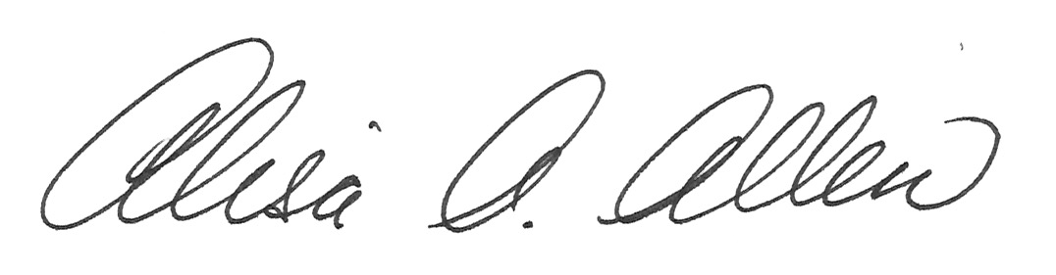
Alisa A. Allen, M.S., P.G.
Owner/Manager

